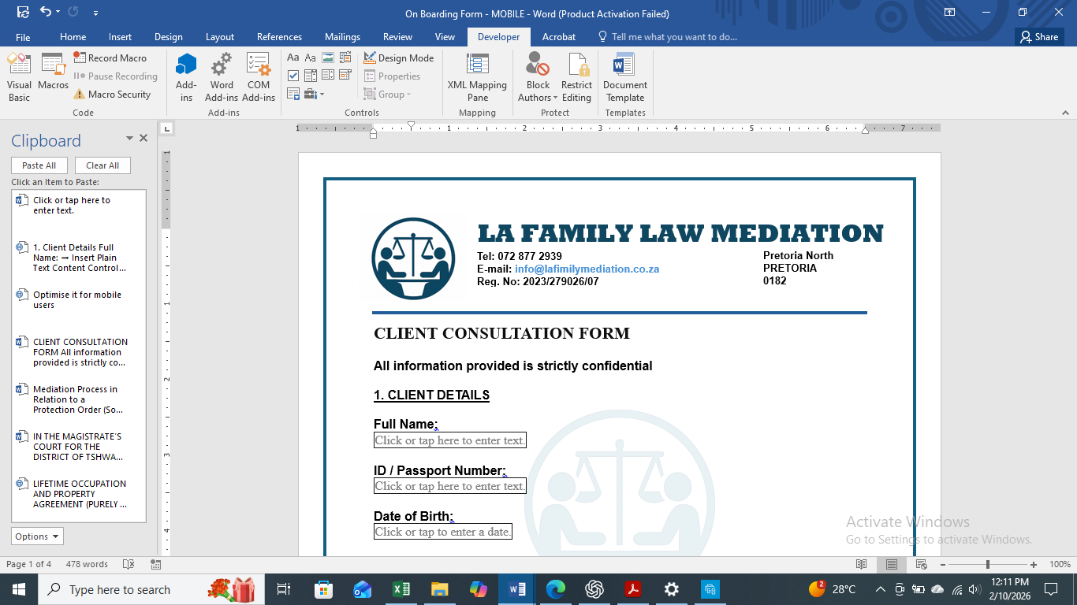

CLIENT CONSULTATION FORM
All information provided is strictly confidential

1. CLIENT DETAILS
Full Name:
Click or tap here to enter text.
ID / Passport Number:
Click or tap here to enter text.
Date of Birth
Click or tap to enter a date.

Contact Number:
Click or tap here to enter text.
Email Address:
Click or tap here to enter text.
Click or tap here to enter text.
Physical Address:

2. OTHER PARTY’S DETAILS
Full Name:
Click or tap here to enter text.
Relationship to Client:
Click or tap here to enter text.
Contact Number (if known):
Click or tap here to enter text.
Email Address:
Click or tap here to enter text.
Click or tap here to enter text.
Physical Address:

3. NATURE OF THE MATTER
☐ Divorce / Separation
☐ Parenting Plan
☐ Child Custody / Contact
☐ Maintenance
☐ Property / Asset Division
☐ Family Dispute
☐ Court-Referred Mediation
Other:
☐ Click or tap here to enter text.

4. BRIEF SUMMARY OF THE MATTER
Click or tap here to enter text.

5. URGENCY
☐ Urgent
☐ Non-Urgent
Click or tap here to enter text.
If urgent, please explain:

6. COURT INVOLVEMENT
Is this matter currently before a court?
☐ Yes
☐No
Click or tap here to enter text.
If yes, please provide details:

7. CHILDREN INVOLVED
Are minor children involved?
☐ Yes
☐ No
Choose an item.
Number of children:

Click or tap here to enter text.
Ages:

8. LEGAL REPRESENTATION / PREVIOUS ACTION
Have attorneys been appointed?
☐Yes
☐ No
Has mediation been attempted before?
☐ Yes
☐ No
Click or tap here to enter text.
If yes, please provide brief details:

9. PREFERRED CONSULTATION METHOD
☐ In-Person → Check Box
☐ Telephonic → Check Box
☐ Online (Zoom / Microsoft Teams / WhatsApp) → Check Box

10. DECLARATION & CONSENT
I confirm that the information provided is true and correct to the best of my knowledge. I understand that mediation is a voluntary, confidential process and does not constitute legal advice. I consent to LA Family Law Mediation processing my information for the purpose of providing mediation services.
Client Signature:
Click or tap here to enter text.
(typing full name is acceptable for digital forms)
Click or tap to enter a date.
Date:

11. POPIA CONSENT & DATA PROTECTION
In terms of the Protection of Personal Information Act, 4 of 2013 (POPIA), I hereby give my voluntary, specific, and informed consent to LA Family Law Mediation to collect, store, process, and use my personal information for purposes directly related to mediation services.
I understand that:
- My information will be treated as confidential.
- My information will not be shared with third parties without my consent, unless required by law or a court order.
- I have the right to request access to, correction of, or deletion of my personal information.
- My information will be retained only for as long as necessary to fulfil the purpose for which it was collected.
Click or tap here to enter text.
Client Name:

Click or tap here to enter text.
Client Signature:

Click or tap to enter a date.
Date:

ATTACHEMENTS:
INSERT PICTURE OF ID / PASSPORT

ALL THE UPLOADED INFORMATION WILL REMAIN STRICTLY CONFIDENTIAL AND STORED IN ACCORDANCE TO THE POPIA.

